Technical Datasheet 4G Gateway

Product Overview:-

The 4G Gateway is an advanced networking device designed to provide seamless connectivity and data management capabilities for various applications. With support for 4G LTE connectivity and TCP Ethernet, cloud connectivity via HTTPS protocol, and robust storage options, it offers a comprehensive solution for remote monitoring and control systems. Equipped with Modbus RS485 port and micro-Sim compatibility, it caters to a wide range of industrial and IoT applications. The intuitive web-based UI interface allows for easy configuration and management, making it an ideal choice for both professionals and enthusiasts.
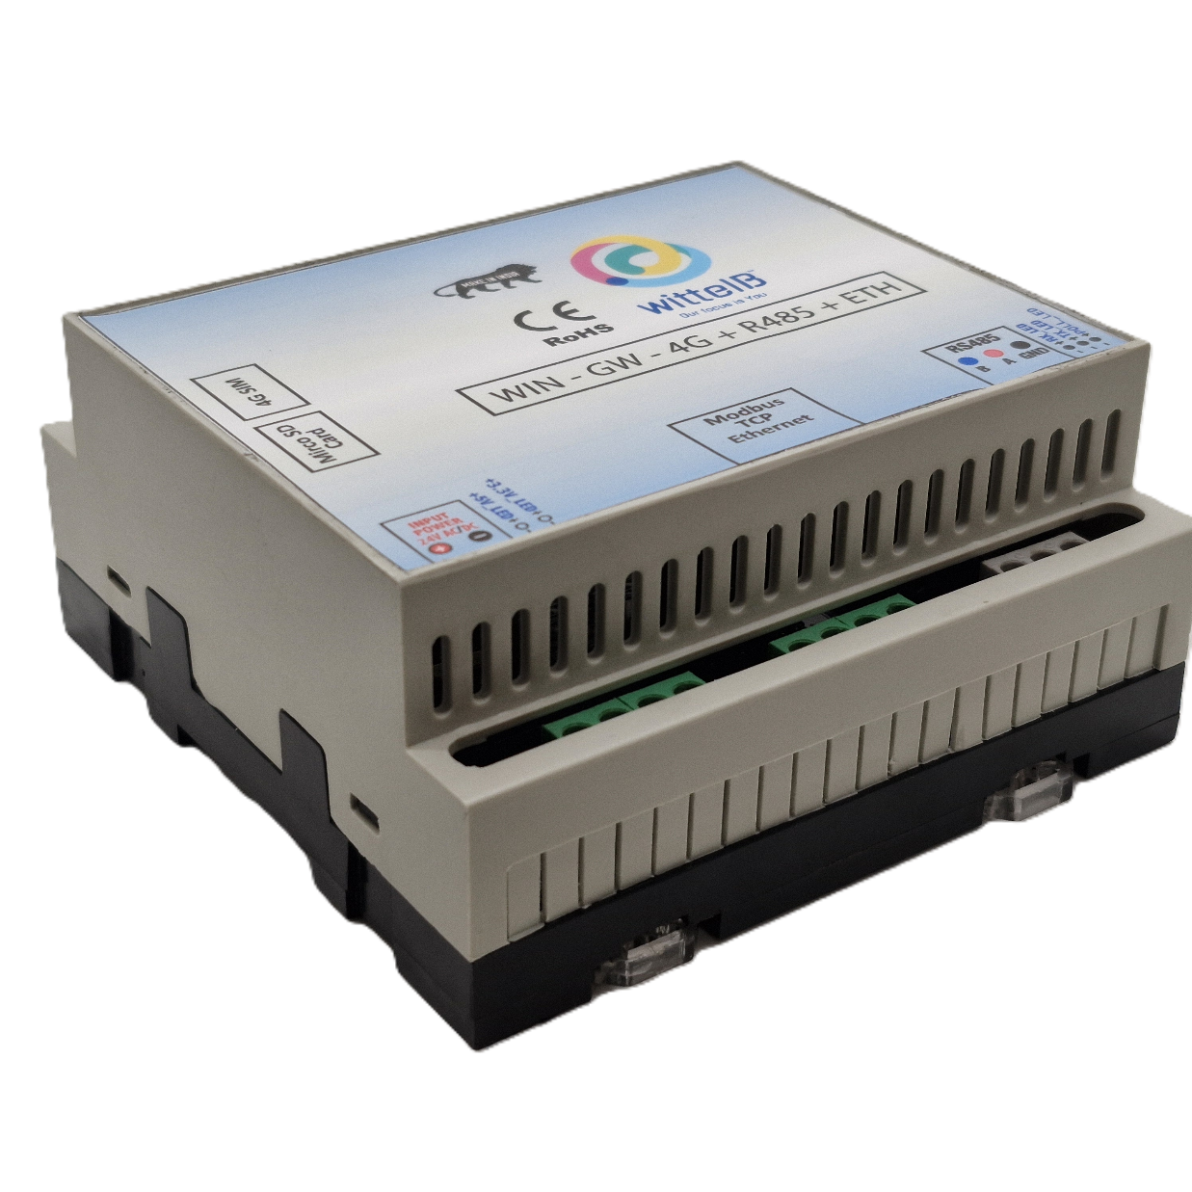

Specifications

General:-
•4G LTE Connectivity: Utilizes 4G LTE technology for reliable and high-speed internet access. If both 4G, Wi-Fi and Ethernet are unavailable, the data is securely stored in the SD card for later upload.
•Cloud Connectivity (HTTPS): Seamlessly connects to cloud platforms using the HTTPS protocol for efficient data transmission and management.
•Event Storage: Offers on board event storage, capable of storing up to 50,000 events or more. Includes an external memory card slot for easy data retrieval in the event of 4G network issues.
•Modbus RS485 Port: Features 1 port of Modbus RS485 for integration with industrial control systems and sensors.
•Micro Sim Compatibility: Supports micro-Sim card for flexible and convenient connectivity option.
•Web-based UI Interface: Intuitive web-based user interface for easy configuration, monitoring, and management.
•Dimensions: 110 mm L x 110 mm B x 50 mm H.
•Power: Input Power – 15-40 VDC, Typical – 12V DC @ 150mA.
•Operating Temperature: 0 – 60C (32 ~ 140F).
•Storage Temperature: 20 - 70C (-4 ~ 158F).
•Storage Humidity: 5 ~ 95 % RH, non – Condensing.

LED Indicators:-
• POWER: Device power status.
• NETWORK: Indicates 4G/Wi-Fi network connectivity.
• CLOUD: Shows HTTPS cloud connection status.
• POLL: POLL/WI-FI: Indicates Modbus polling activity / Wi-Fi mode
• RX: Data received from RS485.
• TX: Data transmitted to RS485.
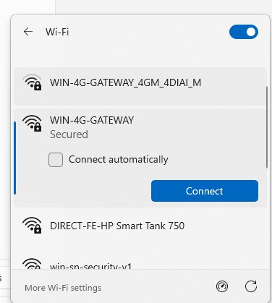

Configuration Settings:
- Power up the module by connecting a 12 V DC supply.
- Insert the SIM card into the designated slot.
- Place the Micro SD card into its designated slot.
- Connect MODBUS RTU Multiple Slave devices (up to 31) to the A & B Terminal
Of Module.
- Access the module's configuration hotspot
(ID: WIN-4G-GATEWAY, PASS: 123456789).
- Default IP Address of Module is “192.168.1.100/cpp1”.
- Upon entering the provided IP address, a configuration webpage
Pages will be accessible.
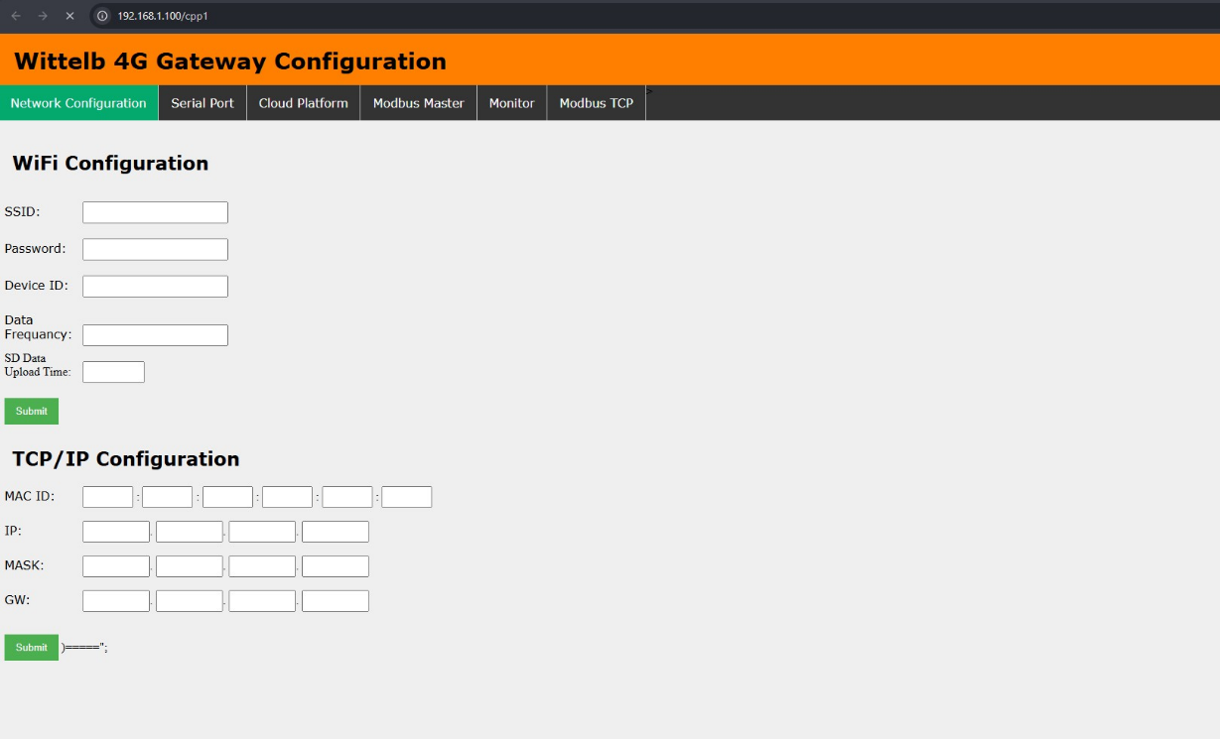
Page 1: -
- Enter Device ID (Should be unique for every device).
- Enter data frequency in min to receive data on cloud.
- Enter time to upload SD card data to cloud.
Page 2:-
On second page you can set device Baud Rate (9600 / 19200 / 38400 / 57600 / 115200), Data Bits (5 / 6 / 7 / 8), Parity (None / Odd / Even), and Stop Bits (1 / 2) for RS485 Communication
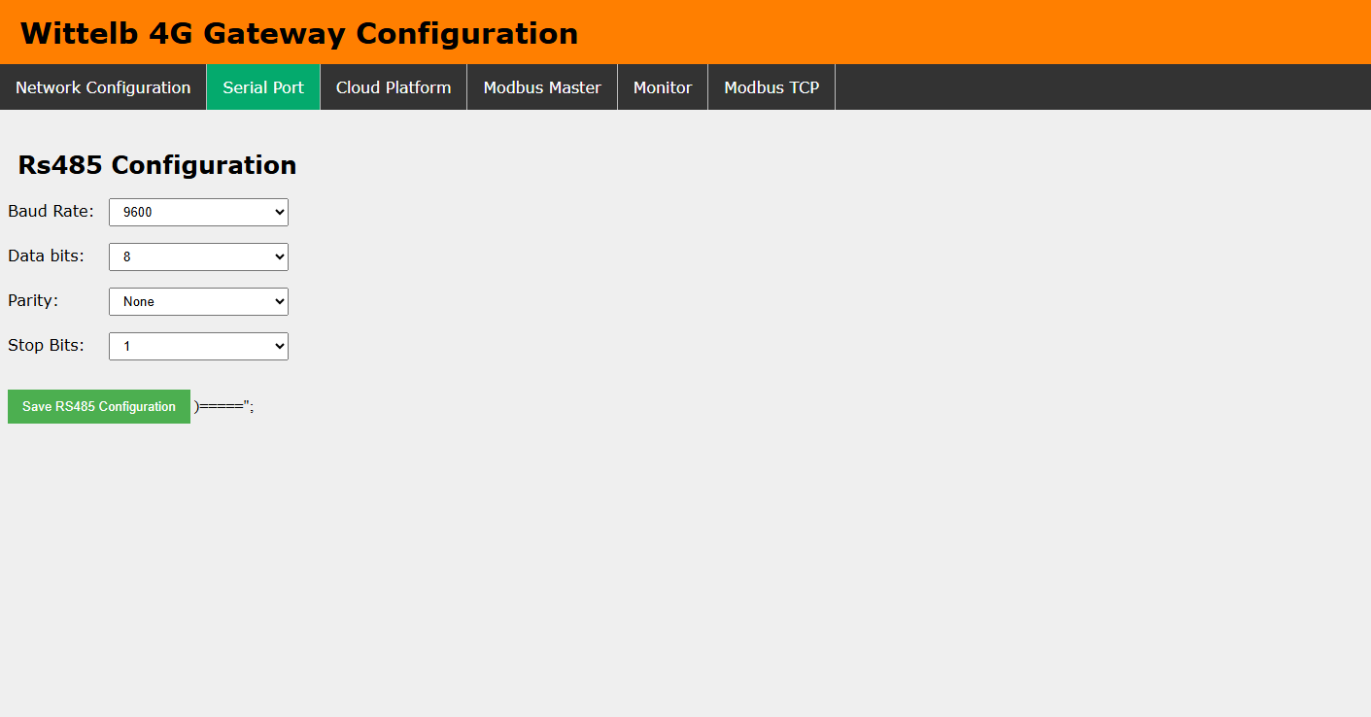
Page 3:-
      - Navigate to page 3 on the cloud platform.
      - Enter the link for the HTTP/s end point URL.
      - Enter the API key/Bearer Token(Optional).
      - Allow a few seconds for the module to restart and establish a connection to HTTPS.
      - Select Wi-fi, TCP and 4G from Which Source you need to send data over HTTPS

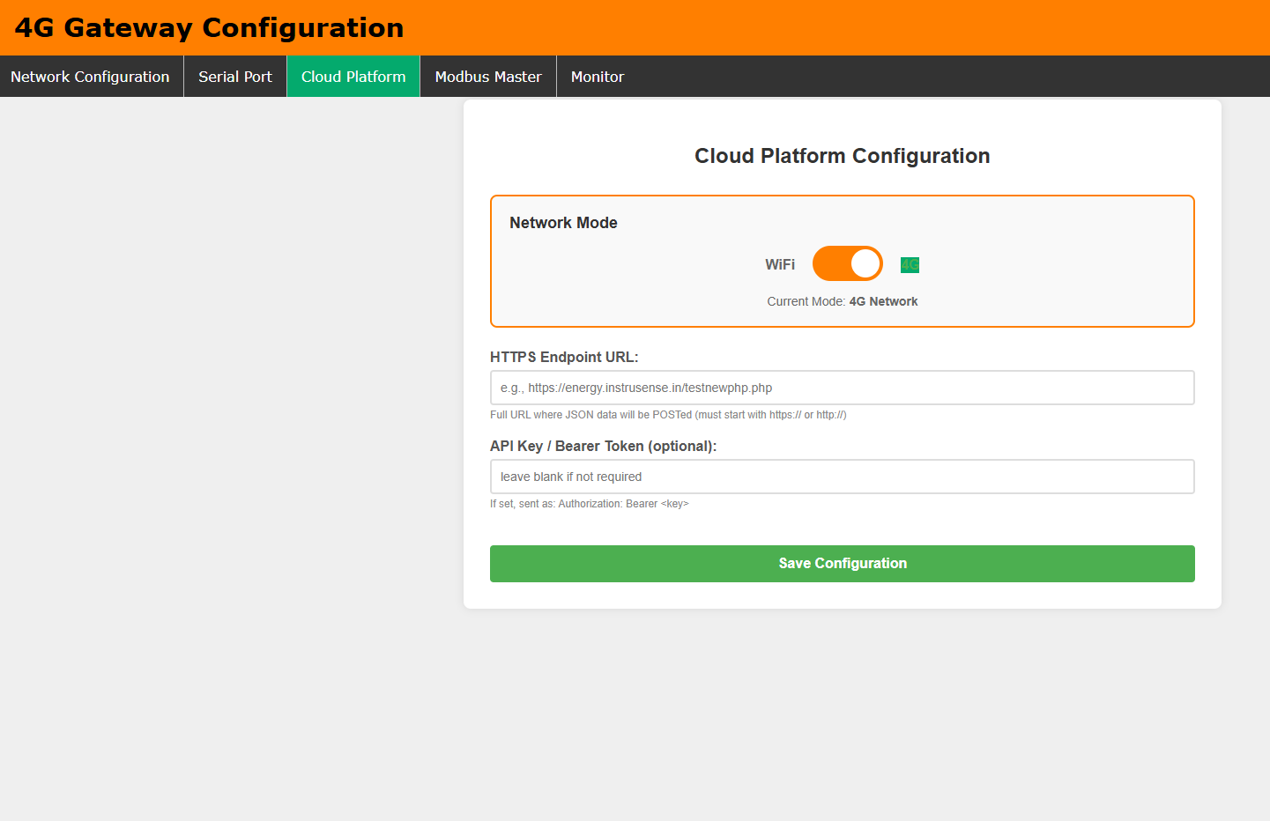

Page 4:-
- Go to page 4 on the Modbus Master interface.
- Input the name and slave address for the designated slave.
- Specify the register address from which you want to read slave data.
- You can enter only the Register which you need to read.
- Select the Data Type: UINT16, Float32 Big Endian, Float32 Little Endian, Float32 BE Byte Swap, or Float32 LE Byte Swap.
- Enter the function code corresponding to the desired slave.
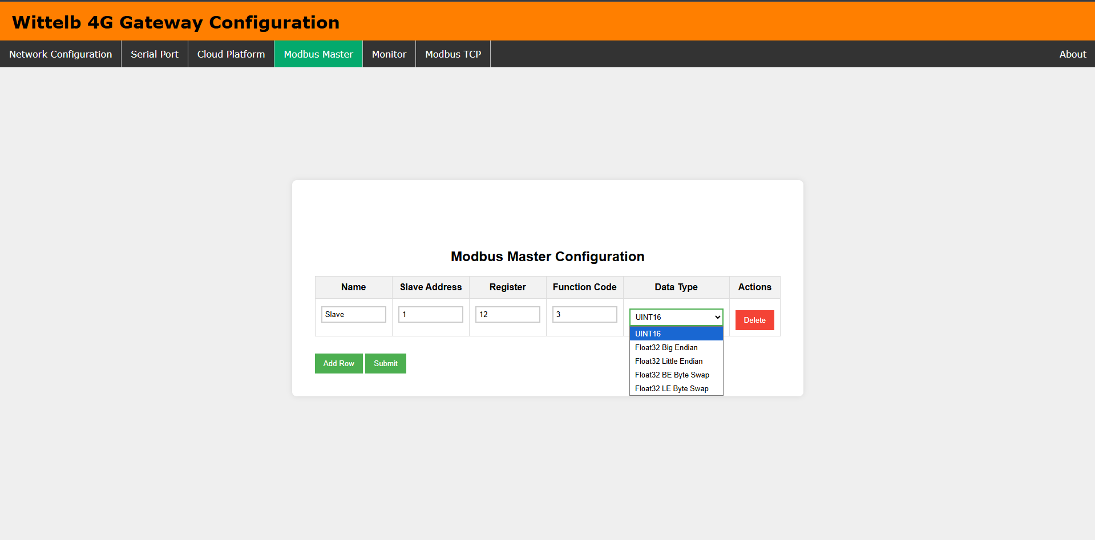
Page5:-
- On page 5 (Monitor), view live Modbus register values for all configured entries.
- Table auto-refreshes every 7 seconds showing: Slave Address, Register, Function Code, Tag Name, Data Type, Live Value, and Status (OK / FAIL)
- Use Slave Address and Register filter fields to narrow down the live view.
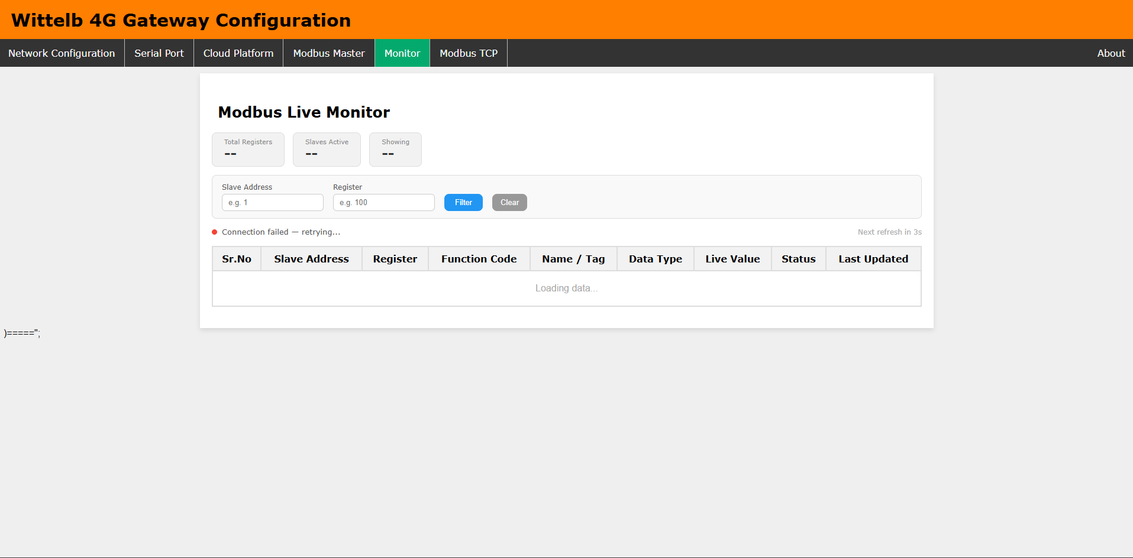

Modbus Slave Configuration:
The gateway supports reading up to 100 individual Modbus points (e.g., sensor values, coil states, pump statuses), stored as entries indexed from 0 to 99. Each entry requires five specific parameters to successfully poll the connected RS485 field devices.

Configuration Parameters:
- Slave Index (0-99): The internal row position for storage on the gateway, which is not transmitted over the Modbus line.
- Slave Name: A custom alphanumeric label (up to 19 characters) used as the JSON key during HTTPS transmission. If left blank, the device auto-generates a name based on the address (e.g., S1_REG40001).
- Slave ID: The hardware RS485 address of the target device, which must be configured between 1 and 31. Multiple entries can share the same Slave ID.
- Function Code: Defines the Modbus reading method. The gateway currently supports Code 1 (Coil Read for ON/OFF status), Code 3 (Holding Register Read for settings/data), and Code 4 (Input Register Read for measured values).
- Data Type: Defines how the raw register data is parsed (applicable only to Function Codes 3 and 4).
  - Type 0: Simple Integer (Reads 1 Register).
  - Type 1-4: Float / Decimal Number (Reads 2 Registers). The 1 through 4 selection alters the byte order; if a float value reads incorrectly, rotating through orders 1-4 typically resolves it. Data type is irrelevant for Coil reads, which always yield 0 or 1.

Register Addressing & Offset Logic:
Modbus datasheet addresses (e.g., 40001) are not transmitted directly to the slave device. The first digit indicates the register type (0 = Coil, 3 = Input, 4 = Holding) and is discarded because the Function Code dictates the type.
Standard Modbus protocol requires subtracting 1 from the remaining digits. Because some manufacturers pre-subtract this offset in their documentation, adding or subtracting 1 is the primary troubleshooting step if a register fails to read correctly.

Datasheet Register | Type Prefix Removed | Final Entered Value (Subtract 1)
40001 (Holding) | 0001 | 0
40010 (Holding) | 0010 | 9
30005 (Input) | 0005 | 4
00001 (Coil) | 0001 | 0

HTTPS Communication & JSON Payloads:
he gateways acts as an HTTPS client, grouping data per Modbus slave address into a single JSON object and transmitting it over the network.

Telemetry Publishing (Device -> Cloud):
- Primary Topic: Data is published to publish_topic, defined in the web-config panel.
- Payload Structure: Each JSON payload includes the Device ID, a Unix timestamp (sent as a string), the integer Slave Address, and the grouped register values using the configured Slave Names.
- Data Formatting: Coil reads produce 0/1 integers, while 16-bit register reads yield plain integers. 32-bit float reads are automatically rounded to 4 decimal places. If a float registers as NaN or infinite, it is transmitted as a null value rather than a number.
- SD-Card Fallback: If the HTTPS connection drops, the JSON payload is saved to the local SD card. Once connectivity is restored, the buffered data is republished unchanged to a secondary topic (pub_topic1).
Command Reception (Cloud -> Device):
- Target Topic: The gateway listens for remote write commands on subscriber_topic.
- Payload Requirements: To trigger a write action, the incoming JSON must contain the target slave Address, the specific register, and the value to be written.
- Execution Limitation: Currently, the HTTPS command engine strictly enforces Modbus Function Code 6 (Write Single Register) for all incoming writes. While the internal firmware supports Coils (FC5) and multi-registers (FC15/FC16), these are not yet mapped to the HTTPS listener.

The following table outlines the JSON payloads handled by the HTTPS engine, their communication direction, and their associated topics.
 | JSON Payload Type | Direction | Topic
1 | IO Board Data | Device -> Cloud | publish_topic
2 | Modbus Slave Data | Device -> Cloud | publish _topic
3 | Write Acknowledgment | Device -> Cloud | publish _topic
4 | SD-Card Fallback Data | Device -> Cloud | publish _topic1
5 | Register Write Command | Cloud -> Device | subscriber_topic
1. Modbus Slave Data (Device -> Cloud)
Sent once per configured Modbus slave address. This payload groups all registers belonging to that specific slave into a single JSON object. Field keys are derived from the user-configured "Slave Name" (e.g., "Voltage", "Current").
{
"DeviceId": "DEV001",
"time": "1725600000",
"slaveAddress": 1,
"Voltage": 230.5000,
"Current": 12.3400,
"PumpStatus": 1
}
(Note: "time" is a Unix timestamp formatted as a string. 32-bit float values are rounded to 4 decimal places before transmission.)

2. Register Write Command (Cloud -> Device)
Sent by the cloud platform to remotely write a value into a holding register. The device will only execute the command if the incoming JSON contains both the register and value keys.
{
"slaveAddress": 1,
"register": 40010,
"value": 1
}
(Note: Currently, the device processes this incoming JSON by issuing a Modbus Function Code 6 (Write Single Register) regardless of the target register's actual data type.)
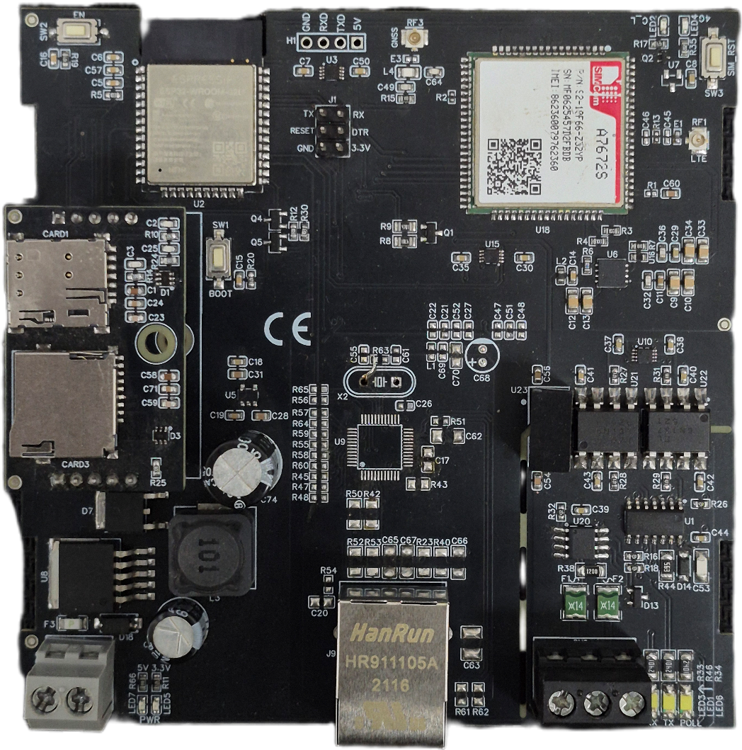
4G Gateway connection Diagram: -
Modbus Port
Pooling LED
24V DC
I/p SPLY
Micro SD Slot
SIM Card Slot
Ethernet Port
Power LED
Network LED

Additional Features: -
Communication ports are isolated
Input power reverse polarity safety
ESD Safety IEC 61000-4-2, ± 30KV contact, ± 30KV air
EFT IEC 61000-4-4, 50A (5/50ms) 400V isolation.

Contact us: -
Augmatic Technologies Pvt. Ltd.,
Plot no 6, Shah Industrial Estate II,
Kotambi, Vadodara – 391510.
Email – Sales@wittelb.com
Support: support@wittelb.raiseaticket.com / +91 94038 92805

